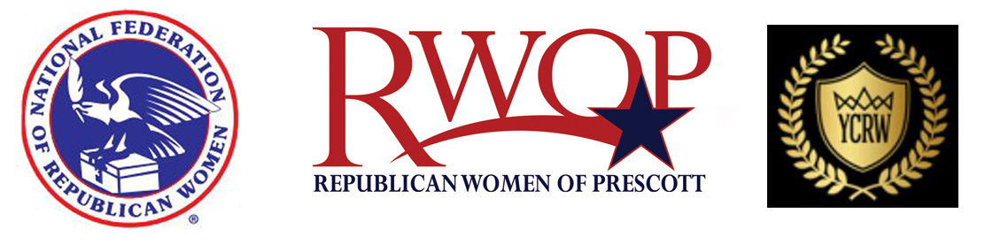
________________________________________________________________________
FOR IMMEDIATE RELEASE: Contact: Pat Lorenzen
Monday, August 29, 2016 928-778-0671 / patricialorenzen@aol.com

National Federation of Republican Women’s ROSIE destination White House bus tour
Rolls through Prescott Thursday, September 1, 2016 on their cross country tour

‘Destination: White House’ Tour Will Register and Rally Voters across the U.S.

The Republican Women of Prescott and the Yavapai County Republican Women are pleased to announce ROSIE the bus “Destination-White House” tour will be rolling through Prescott as she travels the Southwest. The Red Carpet treatment will welcome National Federation of Republican Women, President Carrie Almond on Thursday, September 1st at 5:30 pm with an old fashioned free Ice Cream Social on the historic steps of the Prescott Courthouse.

Come on down to the square, be a part of this FREE event and get involved with what it means to encourage and empower women to vote. Voter Registration will be available at the event. Senator John McCain will be in attendance as will several local political candidates, officials, and AZFRW’s President, Loraine Pellegrino.

“Our mission with the ‘NFRW Destination: White House’ bus tour is to register Republican-leaning women to vote, rally our clubs and communities across the country, and put a Republican back in the White House,” says Almond, of Chillicothe, Mo. “Women’s voices and votes will make the difference.”

Founded in 1938, the National Federation of Republican Women is the largest and most influential Republican women’s group in the nation. The NFRW (www.nfrw.org) proudly represents the party that first made it possible for women to vote in the U.S. Today, the NFRW works to increase the effectiveness and relevance of women in the cause of good government. Our mission remains to recruit and elect Republican candidates and promote the principles of the Republican Party while educating the public and informing the media.

Republican Women of Prescott – P.O. Box 10932 – Prescott, AZ 86304-0932

